## Problem 1 - Darts

**Bay Spiro** picked up his beer and 3 razor-sharp arrows and aimed at the darts board. What he saw was **bay Mile's head** and **right arm** standing in front of the board. What could go wrong?

The rules of the game are as follows:

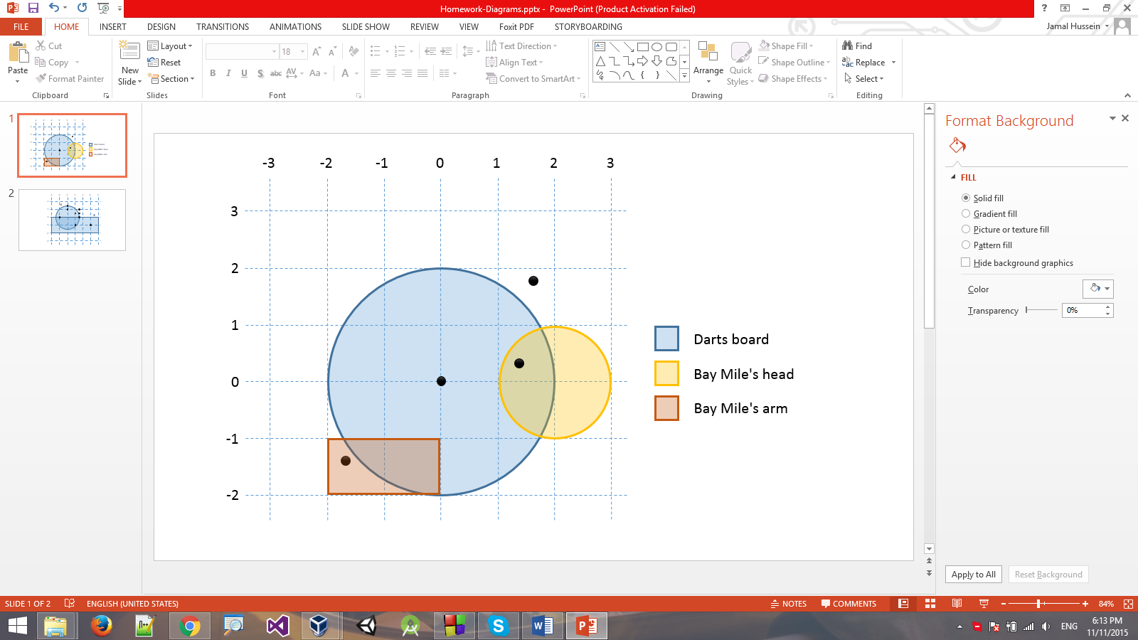Bay Spiro is given **n** dart arrows. He starts with **0 points** and bay Mile starts with **100 health**. If he hits an **area inside the darts board**, bay Spiro earns **50 points**. If he happens to hit bay Mile as well, he is granted only **25 points**.

If he hits bay Mile in the head, bay Mile loses **25 health**. If he hits bay Mile in the arm, he loses **30 health**.

After bay Spiro has thrown all arrows, you must print on the console the following data: **total points**, **board hit ratio** (successfully board hits / total shots made) and bay Mile's **remaining health**.

If bay Mile reaches **0 or less health** at any time during play, the game must end immediately (and he receive his daily Rakia treatment).

### Input

The input will be read from the standard input.

* On the first input line you will receive the coordinates of the darts board and its radius in the format **{boardX} {boardY} {boardRadius}**
* On the second input line you will receive the coordinates of bay Mile's head and its radius in the format **{headX} {headY} {headRadius}**
* On the third input line you will receive the bay Mile's arm coordinates in the format  
  **{topLeftX} {topLeftY} {bottomRightX} {bottomRightY}**
* On the fourth input line you will receive the number of shots **n** bay Spiro will make.
* On the next **n** lines you will receive the coordinates of each shot bay Spiro makes in the format  
  **{shotX} {shotY}**

The input will always be valid and in the format described, there is no need to check it explicitly.

### Output

The output should be printed on the standard output. You must print the **total points**, **successful hit ratio** and **bay Mile's health** (his health cannot fall below 0). The hit ratio should be rounded to the nearest integer (e.g. 66.666 = 66).

### Constraints

* The darts **board** and bay Mile's **head** will always be circles.
* Bay Mile's **arm** will always be a rectangle.
* Bay Mile's head and arm will **not overlap**.
* The input coordinates will be floating-point numbers in the range [-100…100].
* Using C++ is **forbidden**.
* Allowed working time: 0.1 seconds. Allowed memory: 16 MB.

### Examples

|  |  |  |
| --- | --- | --- |
| **Input** | **Comments** | **Output** |
| 0 0 2  2 0 1  -2 -1 0 -2  4  0 0  1.7 1.85  1.3 0.38  -1.7 -1.3 | Hit right in center. **+50 points**  Miss.  Hit board and bay Mile's head. **+25 points -25 health**  Miss board, hit bay Mile's arm. **-30 health** | Points: 75  Hit ratio: 50%  Bay Mile: 45 |

|  |  |  |
| --- | --- | --- |
| **Input** | **Comments** | **Output** |
| 0 0 2  2 0 1  -2 -1 0 -2  8  2 0  3 0  3 0  2 0  0 0  3.2 6.5  7.2 0.3  -5 -3.0 | Hit board and head. **+25 points -25 health**  Hit head. **-25 health**  Hit head. **-25 health**  Hit board and head. **+25 points -25 health** (bay Mile falls to **0 health**, game over) | Points: 50  Hit ratio: 50%  Bay Mile: 0  (hit ratio is 50% - 2 successful shots / 4 fired shots) |